
DATASTRUCTURES AND ALGORITHMS
23CSE203
LAB MANUAL
SUBMITTED BY
NAME | PAVANA HAASINI LATTALA
ROLL NO | AV.SC.U4CSE25033
YEAR/SEM/SECTION | 2ND YEAR/SEM-3/CSE-A
CREDITS | 03

SUBMITTED TO
NAME | DR. RAJ KUMAR BATCHU
DEPARTMENT | SCHOOL OF COMPUTING
DESIGNATION | ASST. PROFESSOR (SL GRADE)
INDEX
S.NO | TITLE | Pg.No | REMARKS
1. | WEEK 1: 1. Recursive countdown from n to Launch.  2. Recursive calculation of compound growth factor.  3. Recursive search for employee ID in list.  4. Recursive factorial calculation for parcel arrangements.  5. Recursive Fibonacci series generation. | 5-13
2. | WEEK 2: 1) write a python program to perform linear search on the given input.  2.a)write a python program to perform binary search on the given input verify by taking sorted array.  2.b) write a python program to perform binary search on the given input verify by taking unsorted array. | 14-20
3. | WEEK 3: a) Write a python program to sort the elements using bubble sort technique. Take an input from the user.  b) Write a python program to sort the elements using insertion sort technique. Take an input from the user.  c) Write a python program to sort the elements using selection sort technique. Take an input from the user.  d) Write a python program to sort the elements using quick sort technique. Take an input from the user.  e) Write a python program to sort the elements using merge sort technique. Take an input from the user. | 21-32

LAB-1
1)AIM: A rocket launch system displays a countdown before launch. Instead of using a loop implement the countdown using recursion .write a recursion python program to display a countdown from n to 1 followed by “launch”.
PROGRAM:
def launch(n):
for i in range(n,-1,-1):
if i==0:
print("launch")
else:
print(i)
n=int(input("Enter no. of seconds to launch:"))
launch(n)

OUTPUT:
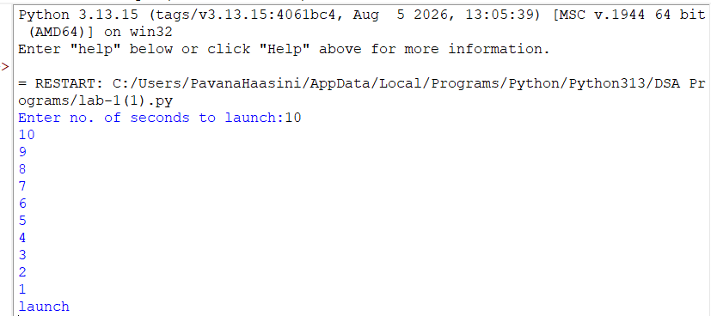

EXPLANATION:
This program displays a countdown from n to 1 and finally prints 'launch'. Although the aim mentions recursion, the given code uses a loop.
ERROR TABLE:
ERROR | CAUSE | SOLUTION
Indentation Error | Statements are not properly indented inside the function. | Indent the for loop and if-else block correctly.
Invalid input | User may enter a non-integer value. | Enter only an integer for the number of seconds
Wrong function call | Launch(n) may be placed before taking input. | Take input first, then call launch(n).

2)AIM: Banks calculate the growth of an investment using compound interest the formula requires calculating powers. Which can be implemented recursively. Write a recursive program to calculate p^n(power),where p=principal growth factor, n= number of years.
PROGRAM:
def interest(p,n):
if n==0:
return 1
else:
return p*interest(p,n-1)
n=int(input("Enter no.of years:"))
p=int(input("Enter a number:"))
res=interest(p,n)
print(res)

OUTPUT:
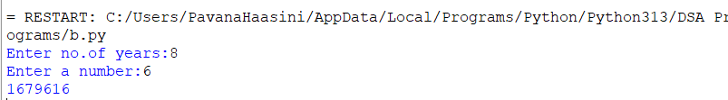
EXPLANATION:
This program recursively calculates p^n by multiplying p until n becomes 0.
ERROR TABLE:
ERROR | CAUSE | SOLUTION
Recursion error | Negative value of n never reaches the base condition | Allow only n >= 0
Value error | User enters a non-integer value | Enter an integer for years and principal
Wrong result | The function calculates pⁿ, not normal simple interest | Use the correct interest formula if simple interest is required

3)AIM: An HR department stores employee ID’s in a list. Develop a recursive program to search for a given employee ID .write a recursive function to search for an employee ID in a list.
PROGRAM:
def search(m):
key=m
for i in range(n-1):
if arr[i]==key:
return i
n=int(input("enter no.of employees to add:"))
arr=[]
for i in range(n):
a=int(input("enter a value:"))
arr.append(a)
print(arr)
m=int(input("enter a element to search:"))
result=search(m)
if result==-1:
print("element is not found")
else:
print("employee id is stored at the index:",result)

OUTPUT:
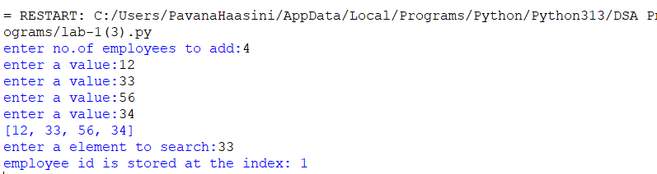
EXPLANATION:
This program searches for an employee ID in a list and returns its index if found.
ERROR TABLE:
ERROR | CAUSE | SOLUTION
Last element not searched | range(n-1) stops before the last index | Use range(n)
Wrong result when element is absent | Function does not return -1 | Add return -1 after the loop
Name error | n is used inside search() as a global variable | Use len(arr) inside the function

4)AIM: In a logistics company the number of possible ways to arrange n different parcels is calculated using the factorial formula(n!). develop a recursive program to calculate the factorial of a given number.
PROGRAM:
def fact(n):
fact=1
for i in range(1,n+1):
fact=fact*i

return fact
n=int(input("enter a number to find its factorial:"))
result=fact(n)
print(result)
OUTPUT:
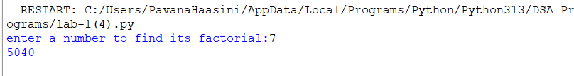
EXPLANATION:
This program calculates the factorial of a number using iteration (not recursion).
ERROR TABLE:
ERROR | CAUSE | SOLUTION
Indentation error | return fact is incorrectly indented | Keep return fact inside the function and outside the loop
Invalid factorial | Negative number is entered | Check if n < 0 and display an error
Value error | User enters a non-integer value | Enter an integer

5)AIM: Write a recursive python program to print the first n terms of the Fibonacci series.
PROGRAM:
def fib(n):
if n==0:
return 0
elif n==1:
return 1
else:
return fib(n-1)+fib(n-2)

n=int(input("enter no of terms:"))
if n<=-1:
print("invalid input")
else:
for i in range(n):
print(fib(i),end=" ")

OUTPUT:
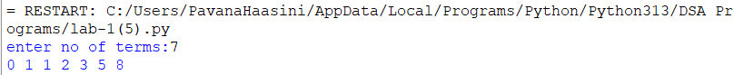

EXPLANATION:
The program uses recursion to generate Fibonacci numbers. fib (0)=0 and fib (1) =1 are the base cases. For every other term, fib(n)=fib(n-1) + fib(n-2). The loop prints the first n terms.
ERROR TABLE:

ERROR | CAUSE | SOLUTION
Invalid input | User enters a negative number | Check if n < 0
Recursion error | Incorrect base condition can cause infinite recursion | Keep base cases n == 0 and n == 1
Value error | User enters a non-integer value | Enter an integer for number of terms

LAB-2
1)AIM: Write a program to perform linear search on a given input.

PROGRAM:
def linear_Search(arr, key):
for i in range(len(arr)):
if arr[i] == key:
return i
return -1
n=int(input("Enter no. of elements:"))
arr=[]
print("Enter Elements:")
for i in range(n):
arr.append(int(input()))
key = int(input("Enter the elements to search:"))
result= linear_Search (arr,key)

if result!=-1:
print("Enter found at index",result)
else:
print("Element not found")

OUTPUT:
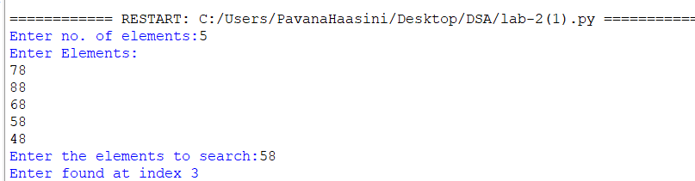EXPLANATION:
This program performs Linear Search to find an element in a list.
It takes the number of elements and their values from the user.
The linear_Search() function checks each element one by one and returns its index if found.
If the element is not found, it returns -1 and displays "Element not found."

ERROR TABLE:
ERROR | CAUSE | SOLUTION
Enter found at index | Typing mistake in the print statement | Change it to Element found at index
linear_Search (arr,key) | Extra space before ( is unnecessary and can make the code look inconsistent | Write linear_Search(arr, key)
Enter the elements to search: | "elements" is plural even though only one search value is entered | Change it to Enter the element to search:

2)AIM: Write a Python program to perform binary search on the given input.
A) SORTED ARRAY:
PROGRAM:
def binary_Search(arr, key):
low = 0
high = len(arr) - 1
while low <= high:
mid = (low + high) // 2
if arr[mid] == key:
return mid
elif arr[mid] < key:
low = mid + 1
else:
high = mid - 1

return -1
n = int(input("Enter no. of elements: "))
arr = []
print("Enter Elements:")
for i in range(n):
arr.append(int(input()))

key = int(input("Enter the element to search: "))
if arr != sorted(arr):
print("Array is unsorted. Binary search cannot be performed.")
else:
result = binary_Search(arr, key)
if result != -1:
print("Element found at index", result)
else:
print("Element not found")
OUTPUT:
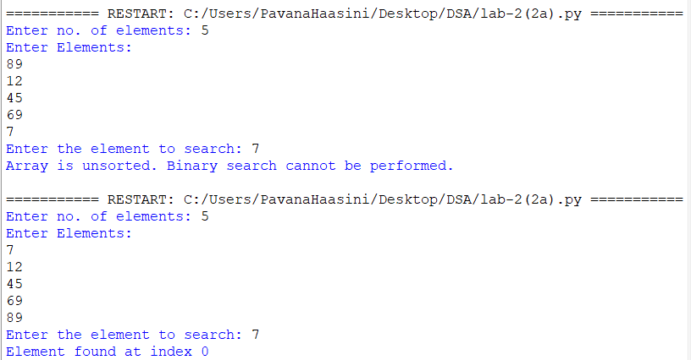B) UNSORTED ARRAY:
PROGRAM:
def binary_Search(arr, key):
low = 0
high = len(arr) - 1
while low <= high:
mid = (low + high) // 2
if arr[mid] == key:
return mid
elif arr[mid] < key:
low = mid + 1
else:
high = mid - 1

return -1
n = int(input("Enter no. of elements: "))
arr = []
print("Enter Elements:")
for i in range(n):
arr.append(int(input()))

key = int(input("Enter the element to search: "))
if arr == sorted(arr):
print("Array is sorted.")
else:
print("Array is unsorted.")
arr.sort()
print("Sorted array:", arr)
result = binary_Search(arr, key)
if result != -1:
print("Element found at index", result)
else:
print("Element not found")
OUTPUT:
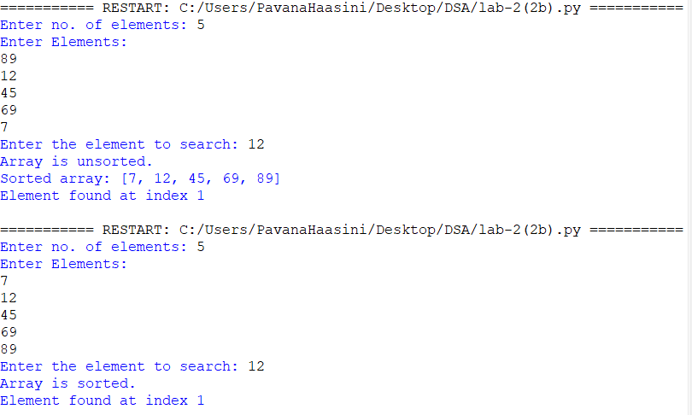EXPLANATION:
This program performs Binary Search on a given array.
It checks whether the array is sorted; if it is unsorted, the program sorts it before performing the search.
The binary_Search() function repeatedly divides the array into two halves to find the required element.
Finally, it displays the index of the element if found, otherwise it displays "Element not found."

ERROR TABLE:
ERROR | CAUSE | SOLUTION
Binary search on an unsorted array | Binary search requires a sorted array | Check the array and sort it using arr.sort()
Incorrect middle index | Wrong calculation of mid | Use mid = (low + high) // 2
Wrong search range | low and high are not updated correctly | Use low = mid + 1 or high = mid - 1
Element not found condition missing | Result -1 is not checked | Use if result != -1
Wrong index displayed | Confusing index with position | Use result + 1 if displaying the position
Searching before sorting | Binary search is performed before arranging an unsorted array | Sort the array before calling binary_Search()

LAB-3
1)AIM: Write a Python program to perform Bubble Sort on the given input.
PROGRAM:
def bubble_sort(arr):
n = len(arr)

for i in range(n):
for j in range(0, n - i - 1):
if arr[j] > arr[j + 1]:

arr[j], arr[j + 1] = arr[j + 1], arr[j]
n = int(input("Enter no. of elements: "))
arr = []

print("Enter the elements:")
for i in range(n):
arr.append(int(input()))
bubble_sort(arr)
print("Sorted array:")
for element in arr:
print(element, end=" ")
OUTPUT:
EXPLANATION:
This program uses Bubble Sort to arrange the elements of an array in ascending order.
It repeatedly compares two neighboring elements and swaps them if they are in the wrong order.
The program takes the number of elements and their values from the user, sorts them, and displays the sorted array.
ERROR TABLE:
ERROR | CAUSE | SOLUTION
IndentationError | Incorrect indentation inside the for loop or if statement. | Maintain proper Python indentation.
ValueError | User enters a non-integer value when int(input()) is used. | Enter only valid integer values.
IndexError | Incorrect loop range may cause access beyond the array boundary. | Use range(0, n - i - 1) as shown in the program.

2)AIM: Write a Python program to perform Insertion Sort on the given input.
PROGRAM:
def Insertion_sort(arr):
n=len(arr)
for i in range(1,n):
key=arr[i]
j=i-1

while j>=0 and arr[j]>key:
arr[j+1]=arr[j]
j-=1
arr[j+1]=key
return arr

n=int(input("Enter no. of Elements:"))
arr=[]
print("Enter Elements:")

for i in range(n):
arr.append(int(input()))

Insertion_sort(arr)
print("Sorted array:")
for element in arr:
print(element, end=" ")
OUTPUT:
EXPLANATION:
The program first takes the number of elements and stores them in the array arr.
The Insertion_sort() function selects each element as key and compares it with the elements before it.
Larger elements are shifted one position to the right, and the key is placed in its correct position.
Finally, the program prints the elements of the array in ascending order.
ERROR TABLE:
ERROR | CAUSE | SOLUTION
TypeError | Comparing incompatible data types, such as a string and an integer. | Convert input values using int(input()).
NameError | Using a variable that has not been defined or using the wrong variable name. | Check and use the correct variable names.
SyntaxError | Missing symbols such as : or brackets in the code. | Check the syntax and add the required symbols.

3)AIM: Write a Python program to perform Selection Sort on the given input.
PROGRAM:
def Selection_sort(arr):
n=len(arr)
for i in range(n-1):
min_index=i
for j in range(i+1,n):
if arr[j]<arr[min_index]:
min_index=j
arr[i],arr[min_index] = arr[min_index],arr[i]
return arr

n=int(input("Enter no. of Elements:"))
arr =[]
print("Enter Elements:")
for i in range (n):
arr.append(int(input()))
Selection_sort(arr)

print("Sorted array:", arr)
for element in arr:
print(element,end=" ")
OUTPUT:
EXPLANATION:
The program first reads the number of elements and stores them in the array arr.
The Selection_sort() function finds the smallest element in the unsorted part of the array.
It then swaps the smallest element with the first element of the unsorted part and repeats this process.
Finally, the program prints the array in ascending order.
ERROR TABLE:
ERROR | CAUSE | SOLUTION
ValueError | Entering a value that cannot be converted into an integer. | Enter only valid integer values.
IndexError | Trying to access an array position that is outside its valid range. | Make sure the loop ranges stay within the array length.
UnboundLocalError | Using a local variable before assigning a value to it. | Initialize the variable before using it.

4)AIM: Write a Python program to perform Merge Sort on the given input.
PROGRAM:
def merge_sort(arr):
if len(arr)<=1:
return arr

mid=len(arr)//2
left=arr[:mid]
right=arr[mid:]

merge_sort(left)
merge_sort(right)
i=j=k=0
while i<len(left) and j<len(right):
if left[i]<=right[j]:
arr[k]=left[i]
i+=1
else:
arr[k]=right[j]
j+=1
k+=1
while i<len(left):
arr[k]=left[i]
i+=1
k+=1
while j<len(right):
arr[k]=right[j]
j+=1
k+=1

n=int(input("Enter no. of elements:"))
arr=[]
print("Enter Elements:")
for i in range (n):
arr.append(int(input()))
merge_sort(arr)
print("Sorted array:")
for element in arr:
print(element,end=" ")
OUTPUT:
EXPLANATION:
The program uses Merge Sort to arrange the elements of the array in ascending order.
The merge_sort() function divides the array into two smaller parts repeatedly until each part contains one element.
It then compares and merges the smaller parts in the correct order to form the sorted array.
Finally, the program prints all the elements of the sorted array.
ERROR TABLE:
ERROR | CAUSE | SOLUTION
RecursionError | The function keeps calling itself without reaching the stopping condition. | Make sure the base condition if len(arr) <= 1 is present.
AttributeError | Trying to use an array operation on an inappropriate data type. | Make sure arr is a list before passing it to merge_sort().
UnboundLocalError | A local variable such as i, j, or k is used before being initialized. | Initialize the variables before the while loops.
5)AIM: Write a Python program to perform Quick Sort on the given input.
PROGRAM:
def quick_sort(arr, low, high):
if low < high:
pivot = arr[high]
i = low - 1

for j in range(low, high):
if arr[j] <= pivot:
i += 1
arr[i], arr[j] = arr[j], arr[i]

arr[i + 1], arr[high] = arr[high], arr[i + 1]
p = i + 1
quick_sort(arr, low, p - 1)
quick_sort(arr, p + 1, high)
n = int(input("Enter no. of elements: "))
arr = []

print("Enter the elements:")
for i in range(n):
arr.append(int(input()))

quick_sort(arr, 0, n - 1)

print("Sorted array:")
for element in arr:
print(element, end=" ")
OUTPUT:
EXPLANATION:
The program uses Quick Sort to arrange the elements of the array in ascending order.
The quick_sort() function selects the last element as the pivot and places smaller elements before it and larger elements after it.
The array is then divided into two parts, and the same process is repeated recursively for both parts.
Finally, the program prints the sorted array.

ERROR TABLE:
ERROR | CAUSE | SOLUTION
TypeError | Passing incorrect data types to quick_sort() or comparing incompatible values. | Make sure the array elements and low/high values are integers.
RecursionError | Recursive calls do not reduce the sorting range properly. | Ensure recursive calls use p - 1 and p + 1 as shown.
ZeroDivisionError | Incorrectly using division in calculations for the pivot or index. | Use integer indexing and avoid unnecessary division.

